**MACM 316 – Computing Assignment 5 Report**

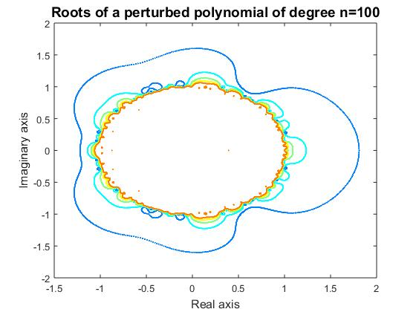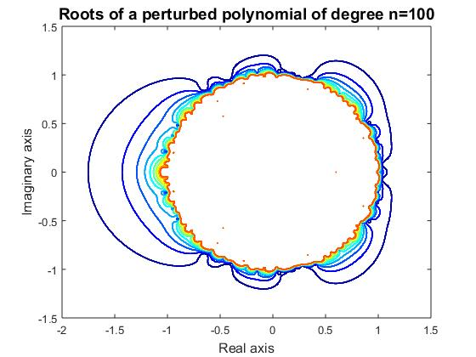

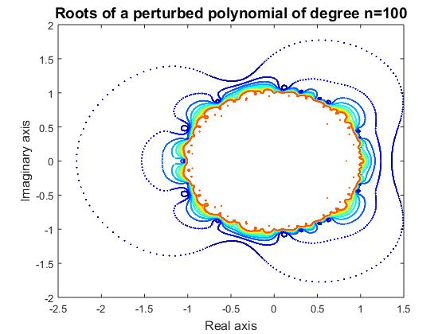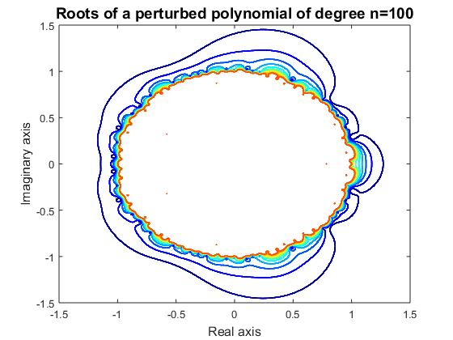

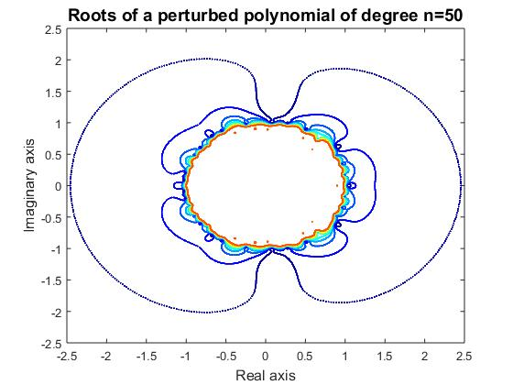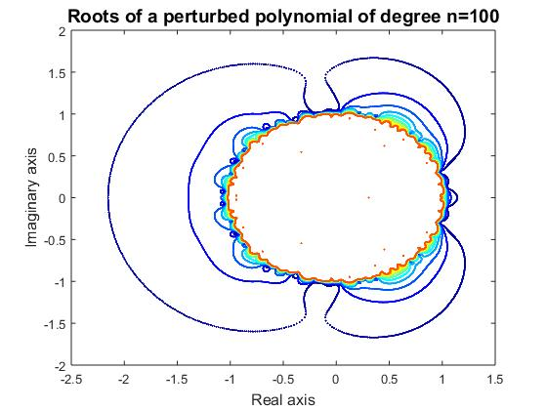

Observing the two figures on the first row, we can see that the left figure has less layers than the figure on the right. Both figures were implemented under the same degree and theta values, the only difference between them is the maximum radius value. The left one was implemented with maximum radius value of 5, and the right one was implemented with maximum radius value of 10. Clearly, the greater the maximum radius value is, the more layers there are. Secondly, observing the two figures in the second row, we can roughly see that both figures have the same amount of layers, but the root data points on the outer layer of the left figure are not plotted continuously as a curve. This is because two of them have different values of theta stepsize when they were implemented with identical degree value and maximum radius value. The left figure was plotted with theta stepsize of PI/50 and the right figure was plotted with theta stepsize of PI/200 both from 0 to 2*PI. We can conclude that the greater the theta stepsize is, the sparser the root data points are in the angular motion. At last, the bottom two figures were plotted with the same maximum radius values and the same theta stepsizes, but one with degree of 50 and the other one with degree of 100 showing at the titles. As shown from the figures, two of them do not vary so much in terms of the shape because their perturbation values theta and radius are identical.